# CASE STUDY: Grandmaster

How the SEO strategies from Intuisyz helped an animal nutrition company get more customers and increased visibility to vendors and suppliers.

## The Client

Our client, Thaliyan Group, is a leading cattle feed manufacturing company in Cochin, Kerala. Their premium brand, Grandmaster Cattle Feed, is a range of high-quality feed products that support the nutrition and health of livestock, following the best global nutritional policies.

## The Problem

As the competition in the cattle feed industry intensified, Grandmaster recognized the need to enhance their online presence and generate new business opportunities through their website. Grandmaster approached us with the primary objective of optimizing relevant product keywords to drive organic traffic growth. The specific goals were as follows:

* Increase organic traffic to the Grandmaster website.
* Improve keyword rankings for product-related search queries.
* Generate new business opportunities through the website.

The main challenge was to optimize relevant product keywords to improve search engine rankings. Grandmaster needed their website to appear prominently in search results when potential customers searched for cattle feed products in their target market.

## The Strategy

We devised and executed a comprehensive SEO strategy to achieve Grandmaster's goals. The key steps involved were as follows:

### Backlink Quality Improvement:

We thoroughly audited Grandmaster's backlink profile to identify low-quality or spammy links. We then implemented a strategic approach to acquire high-quality backlinks from authoritative websites relevant to the cattle feed industry. This process included outreach, guest posting, and building relationships with industry influencers, resulting in a more robust and reputable backlink profile.

### Content Marketing:

We developed a content marketing strategy to create informative and engaging content related to cattle feed, livestock nutrition, and industry trends. This approach attracted organic traffic and positioned Grandmaster as a knowledgeable and trusted resource within the industry.

### Analyzing the SEO metrics:

### To measure the website performance, we regularly analyzed the SEO metrics like organic traffic, organic keywords, traffic value and organic positions. This helped to determine top-performing pages, top-converting keywords and areas of the website that need to improve search rankings. Below are the details of the metrics analyzed:

Tracking performance and progress: Ahrefs Rank 210, 6146

**1. Organic Traffic**

The widget below summarises the website’s organic traffic from 2020 to 2023. It shows how much our website traffic gets compared to all other sites on the internet. From the below metric, in Jan 2020, the growth was in baseline, then we can see a change from 2021, and in Jan 2022, it reaches the peak point.

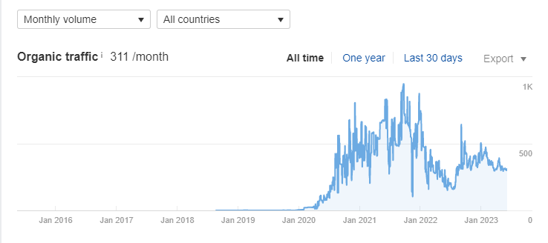

**2. Organic Keyword**

By analysing these results, we identified new keyword opportunities and competitors. The below metric shows the growth was on the baseline up to the middle of 2020. From there onwards, a change in growth was seen, and now, in 2023, achieved a good position in the industry.

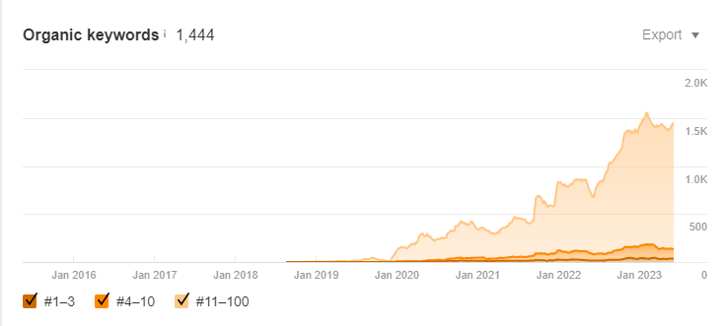

**3. Organic Traffic Value**

Number of visits to website from organic or paid search traffic

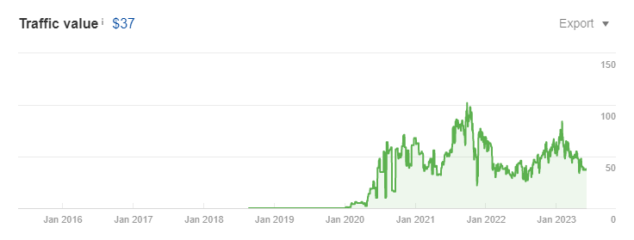

This report shows which website pages receive the most organic traffic.

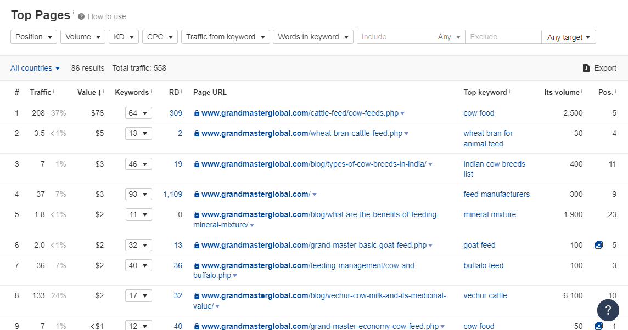

**4. Organic Positions**

This graph shows the estimate based on the search volume and weighted rank positions of the keywords.

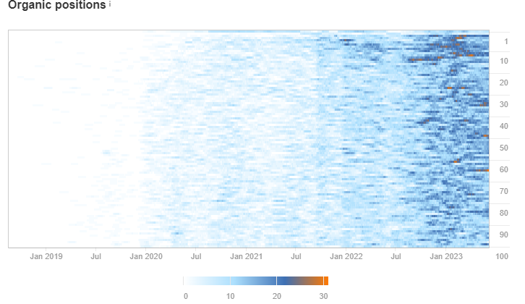

## The Results

**Organic Traffic Growth**: Grandmaster's website experienced a notable increase in organic traffic through the implemented strategies. The improved backlink profile and optimized product keywords contributed to attracting highly relevant visitors interested in cattle feed products. This influx of targeted traffic presented new business opportunities for Grandmaster.

**Keyword Rankings**: The optimization efforts led to improved keyword rankings for relevant product-related search queries. Grandmaster's website gained higher visibility on SERPs, increasing exposure to potential customers searching for cattle feed solutions. One hundred relevant product-related keywords were positioned on the first page, and 36 keywords ranked within the first three pages.

**Business Opportunities**: The increase in organic traffic translated into tangible business opportunities for Grandmaster. The higher visibility and improved online presence attracted potential customers, leading to new international enquiries, increased sales, and overall business growth. The SEO strategies implemented not only attracted potential customers but also increased visibility to vendors and suppliers. As a result, the company established more substantial relationships with vendors, facilitating smoother operations and potential partnerships.

## The Conclusion

The Grandmaster case study shows how a comprehensive SEO strategy by Intuisyz resulted in a significant boost to their business. The combination of content marketing and link-building efforts yielded tangible results and helped them establish a more substantial online presence within their niche.